SOUNNESS PARK VENUE HIRE FORM
Please note, this form is for hire of the grounds and changerooms only. For hire of the venue’s Clubrooms including kitchen and meeting rooms please refer to the Plantagenet Sporting Club by emailing contactus@plantagenetsportingclub.org.au.

Applicant’s Name: | .
Postal Address: | .
Contact: | .
Telephone: | . |  | .
 | (Daytime) | (After Hours)
Mobile: | .
Email: | .

 | Venue Hire Requested: (to define oval locations please refer to the map at T&Cs, Point 9 on page 7)
Eastern Oval (Football) |  | ☐ |  | Western Oval (Cricket) | ☐ |  | Hockey Gound | ☐
 | If Eastern Oval or Hockey Oval, please tick the following if required:
 |  |  | Floodlights  (Fees apply) |  | ☐ | Scoreboard |  | ☐

Changeroom Facilities Requested – if applicable (please see attached plan on page 2)
Changeroom 1 | ☐ | Fees apply
Changeroom 2 | ☐ | Fees apply
Changeroom 3 | ☐ | Fees apply
Changeroom 4 | ☐ | Fees apply
Umpire Room 1 | ☐ | No fees apply
Umpire Room 2 | ☐ | No fees apply

Number of people: |  | .
Hire Date(s): | From: | . | To: |  | .
Commencement of Hire |  | . | End of Hire |  | .
 |  | (Time) |  |  | (Time)
OR
Sporting Club – Fixtures for Games and Training Attached |  |  |  | ☐
Please note that the changerooms can be used by any hirer, any time, so they will always have to be cleaned and tidied after games. Clothes and equipment will need to be stowed in the respective club storage rooms between games.

Plan of Changerooms

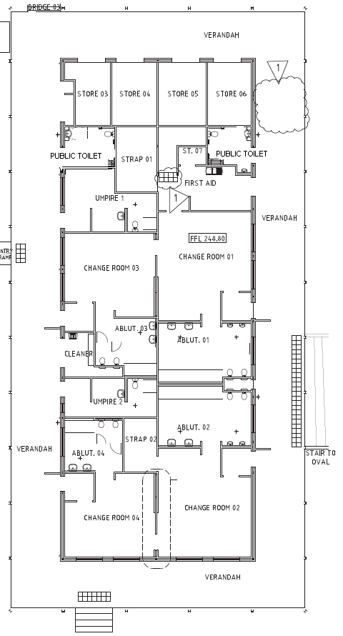

Change Rooms
Umpire Rooms
Account Details For Return Of Bond
Name of recipient (individual or group): | .
Name of Account: | .
BSB: | .
Account Number: | .
Signature:

Additional Requirements
Ten bins are provided as part of your hire.  Please insert the number of additional bins required, if applicable (fees apply) | .

Do you plan to mark the oval, use star pickets or otherwise disturb the oval surface. | Yes ☐ No ☐
If Yes, please provide details:
.
.

Will alcohol be consumed during the hire (outside the clubrooms)? | Yes ☐ | No ☐
Will alcohol be sold during the hire (outside the clubrooms)? | Yes ☐ | No ☐

A user group may apply / receive an 'Occasional Liquor Licence' for an event outside of the licensed bar area in the Sounness Park Clubrooms. If alcohol is to be sold, you will be required to obtain an Occasional Liquor Licence from the Department of Racing, Gaming and Liquor (Phone: (08) 6551 4888 or visit: www.rgl.wa.gov.au). From 1 July 2025 please refer to Department of Creative Industries, Tourism and Sport.

Declaration by Applicant

I am over the age of 18 years and hereby agree that the above booking details are tentative until confirmed by the Shire of Plantagenet. I agree to indemnify the Shire of Plantagenet against all actions, claims, demands and costs arising out of or in connection with the hire of this facility.

I have read and understood the terms and conditions for Shire of Plantagenet Venue Hire. | ☐
I have read and understood the evacuation procedures provided to me. | ☐

Name: | . | Signature
Date: | .

 | OFFICE USE ONLY |  |  |  |  | Synergy Ref:
 |  | Approved |  | Sign off |  | Comments/Conditions
 | Booking Availability | Y ☐ N ☐
 | Executive Manager Infrastructure & Assets | Y ☐ N ☐
 | Environmental Health Officer | Y ☐ N ☐
 | Manager Community and Recreation Services | Y ☐ N ☐

Booking Advice
Booking confirmed | Y ☐ N ☐ | Subject to above conditions being adhered to and the payment of a bond of $ _____________.
Booking Officer: | Name:
 | Signature:
Debtor Invoice Raised: | Y ☐ N ☐

TERMS AND CONDITIONS

Hiring Sounness Park
- The hirer is required to be 18 years of age or older and the Council may request proof of age prior to accepting the booking. The Council reserves the right to refuse any booking. Commencement and conclusion times stated on the Application for Venue Hire form must include the times required for setting up prior and cleaning up after the event (Disregard for fixtured sporting events).
- Fixtures are required from the clubs to enable bookings of the oval and changerooms. The Shire will not take large scale bookings without a formal fixture list. A venue hire form is to be completed by each code for each season.
- Please note that the changerooms can be used by any hirer, any time, so they will always have to be cleaned and tidied immediately after events, including fixtured games and training. Clothes and equipment will need to be stowed in the respective club storage rooms between games. Foundation Clubs must store large items of equipment, such as exercise bikes and fridges in their store rooms between seasons.
- Bookings of an oval by itself will include the two public toilets located near the tennis courts. The Shire will ensure that these public toilets are opened and closed at appropriate times and cleaned afterwards. Where the booking includes the changerooms, hirers are expected to open the two public toilets in the changerooms building (see attached plan) for the event and close those toilets afterwards. The Shire will clean the public toilets after events.
- For bookings including changerooms, a blue swipe tag will be provided with the instructions on its use.
- Slip-in signs have been provided for changerooms so that users can assign the required gender.
- No events will be permitted on Sounness Park that have the potential to penetrate the surface of the grassed areas. Star pickets and tent pegs may be approved, but details must be provided for consideration by the Work and Services Department.
- Use of floodlights on the eastern oval is at the cost specified in the Shire’s annual budget. Swipe tags are required to operate the lights (one tag for competition standard and one tag for training standard). Instructions will be issued with the tags. An invoice will be sent to the hirer as soon as possible after the event for ad hoc events and on a monthly basis for fixtures.
- Use of floodlights on the hockey ground is at the cost specified in the Shire’s annual budget. Please discuss requirements with Shire staff.
- Hires of the oval include a standard rubbish bin allocation of 10 bins. Additional bins will incur an additional charge of $50.00 for 5 bins or part thereof.
- Any requirement to pick up rubbish around the oval or properly clean any part of the changerooms which have been hired will result in the works being carried out by the Shire and bond money being used.
- An electronic score board is provided on the eastern oval. This is operated from a computer in the scorer’s box. An induction will be required if users have not previously used the equipment. A ‘garage door’ type remote control is required to open the score board cover. This is kept in a lock box in the scorer’s box.

Lights and Hot Water System
The lights in the change rooms are automatic and are operated by motion detectors fitted inside the change rooms. They will come on when you first open the doors and remain on while there is movement.

Upon completion of hire there is no need to do anything with the lights as they will turn themselves off after a set period of time with no movement in the building.

The hot water system has been turned on, is fully operational and should be left on.

Fees and Bond
The Shire’s budget includes a fee structure for Sounness Park, which provides that no fees will be charged for any use of playing surfaces, fees are payable for use of the changerooms as there will be an ongoing cost to the Council for maintaining changeroom facilities in good order.
Changerooms have been fitted with electronic doors which can record blue key access entries. Charges will be made for any usage that has not been captured as part of the application process.
A bond is required to cover keys / tags, cleaning, damage and additional usage is required prior to use of the facility. No booking is confirmed until payment of the hire fee and bond are paid in full.
Bonds for Ad hoc Events
Arrangements will be made for the refund of the bond on return of all keys / tags and receipt of advice from the Inspection Officer that the facility has been left in a clean and tidy condition. Additional cleaning costs and damage in excess of the bond amount may be invoiced to the user. Note that bond moneys may take up to ten days to be returned.

Bonds for Fixtured Sports
The bond applies to each Code playing at Sounness Park. Bookings will not be confirmed until the bond is paid. Also, no access will be given to the changerooms unless the bond is at set amount (Blue swipe keys can be activated and deactivated). Bond inspections will be carried out every Monday after weekend games. Hirers will be advised by email or telephone that work has been carried out using bond moneys and the bond has therefore fallen below the required amount. The bond will need to be returned to that level before entry is reinstated to the changerooms.

Compliance with Legislation
Hirers must comply with legislation relating to the use of the Council amenities. The hirer shall comply with the provisions of the Health Act, Liquor Control Act, Police Act, and Environmental Protection Act (relating to excessive noise), or any other relevant legislation and the Council’s Local Laws.

Public Liability Insurance
Incorporated bodies, sporting clubs or associations of any kind and other persons conducting profit making or commercial ventures shall have public liability insurance of at least $10,000,000. Such organisations and activities are expressly excluded from cover under the Shire of Plantagenet’s Casual Hirers Liability insurance.

No Smoking Policy
Sounness Park is deemed a NO SMOKING AREA.

Equipment
Five chairs are situated in the scorer’s box, a table and chairs are in Umpire Room 1 and a first aid bed is in the First Aid Room. No other furniture is provided as part of the booking fee. Should any additional tables and chairs be required, they are to be sourced at the hirer’s expense.
Sporting Clubs may provide beds, chairs and fridges etc in the strapping rooms indefinitely at their own risk.
Extreme care must be taken in transporting and positioning tables and chairs, in order that such equipment does not damage the floor or walls. A charge will be applied for any maintenance or additional cleaning required.
Hirers are to provide their own first aid kit.

Guests
Hirers are responsible for the actions of guests/members whilst using the facility. Equipment and goods left within the facility are left at the hirer’s/owner’s risk. The Council accepts no responsibility for any items left on the premises after the completion of functions.

Map to Define Oval Areas

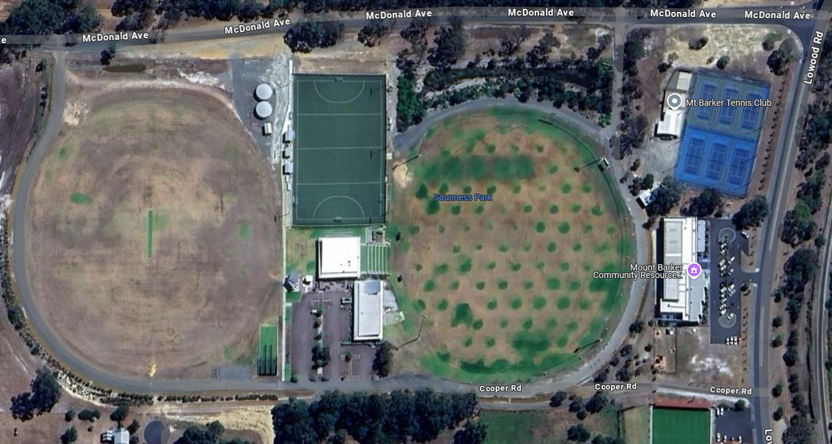
Western Oval
Eastern Oval
Hockey Oval

Hired Area
Under no circumstances is the hirer permitted to penetrate, drill, drive tacks, nails, screws or affix adhesive materials, etc into or on any of the woodwork or walls or any part of the building, equipment or fixtures, without prior permission of the Shire of Plantagenet.
The hirer must ensure that:
- No lights or lighting fixture is interfered with in any way.
- All decorations, including flowers and all equipment used in excess of equipment provided by the Council are removed immediately the period of hire terminates.
- No damage is caused to the building or any property, chattels, equipment, fixtures or fittings contained in the building.
- No Council property, chattels, equipment, fixtures or fittings are removed from the facilities.
- No inconvenience is caused to the owners or occupiers of property in the vicinity of the facilities.

Floors
If floors are damaged in any way, a charge against the bond can be made for restoration.

Cleaning
Paper towels, toilet paper, hand soap, and rubbish bins have been provided.
The hirer shall return all equipment to its designated area. All rubbish must be removed and all areas used are to be left in a clean and tidy condition by the time the period of hire terminates. A Cleaning Schedule is attached for your information.
Hirers will be charged for any additional cleaning time required. The Shire of Plantagenet accepts no responsibility for any items left on the premises after the completion of functions.

Curfew
The curfew for Council facilities is 1.00am. Music and refreshments must end at the hire time designated by the hirer and are not permitted to go later than this curfew. Please ensure that you have vacated the building at the agreed time. Failure to do so may result in additional charges.

Security, Callouts and Keys
Upon completion of your hire please ensure all doors are shut and locked and the building is left in a clean and tidy condition as you found it. If the Caretaker or Security is called out after hours to secure a building, the hirer at fault will be billed costs accordingly.

Cancellation or Change Request
There is no fee for cancelling your hire. However, if you need to cancel or change your venue booking the hirer must submit a completed and signed ‘Update Or Changes To Venue Hire’ form. This form is available from the Administration Reception or by emailing info@sop.wa.gov.au.

Cleaning Schedule and Evacuation Procedure
The following Cleaning Schedule and Evacuation Procedure form part of these terms and conditions of hire.

CLEANING SCHEDULE

The hirer is responsible for supplying cleaning fluids, cloths, sponges etc, as these are not included in the hire. A mop, bucket and broom are located in the changerooms.

Before leaving the building, please ensure the following items are completed:
- Wipe down all bench tops and seats.
- Wipe over all mirrors.
- Wipe down all tiled surfaces.
- Sweep and mop all floors.
- Empty all rubbish bins.

When the rubbish bins in the rooms you have hired need to be emptied, please remove the rubbish bin liner bag from the bin and put it in the external bins provided.

You will find new replacement bags in the bottom of the bin; please replace the liner each time the bin is emptied.

If the facility requires additional cleaning to be carried out by Council staff, then a cleaning fee will be deducted from your bond (cleaning fees are as set out in the Shire of Plantagenet Annual Budget).

EVACUATION PROCEDURES

In the interests of public safety, the venue hirer should nominate a number of responsible persons from their group who will be present during the entire hire period to act as safety wardens in the event of an emergency. Those safety wardens will be responsible for ensuring the safe and orderly evacuation of all rooms and buildings occupied by the group and co-ordinating the following functions and responsibilities.

Safety wardens should be familiar with the layout of the building, rooms, facilities, exit pathways and evacuation muster points associated with the areas being occupied by their group.

Anyone discovering a fire should
- Immediately call ‘Fire, Fire, Fire’.
- If possible, determine the cause and severity of the fire.
- Commence evacuation if required.
- Extinguish the fire if safe to do so.
- Ring the Fire Brigade on 000.

Evacuation
- Assist anybody in immediate danger, only if safe to do so.
- When evacuating, move through exit doorways in an orderly fashion. Heat, fire and smoke will present the greatest hazard. Visibility may be restricted. Passageways may be inaccessible or too dangerous to use. Escape routes and exits, as well as normal footpaths for leaving a building, should be assessed for the safest exit route.
- Move to the assembly area and remain there until advised by the co-ordinator.
- Check to see that all people within the building are in the assembly area.
- Do not re-enter the building at any time, unless under instruction by an authorised person.

Contact
- When all building users have been safely evacuated and the Fire Brigade has been notified, contact the Shire of Plantagenet Chief Executive Officer on 9892 1111.

